Some Questions

1)
The breadcrumb navigation doesn’t work correctly.
If I go to a page in the 2nd of 3rd level the breadcrumb will only show „Home“ / and „page name“. Where are the pages between?

2)
The navigation doesn’t show the status correctly.
Here some examples in screenshots:

Site structure (Admin/Pages)
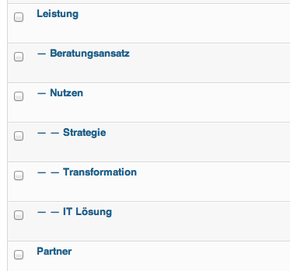

Menu structure (Admin/Menu)
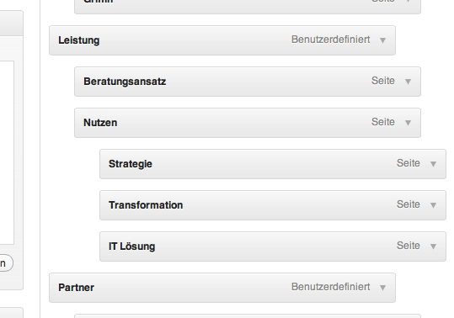

Top Menu (Website) looks good
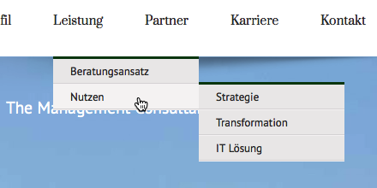´

If I cklick on „Nutzen“ (the parent of „Strategie“, „Transformation“ and „IT Lösung“) the navigation on the website looks intresting... Why are the 3rd level sites active in menu?

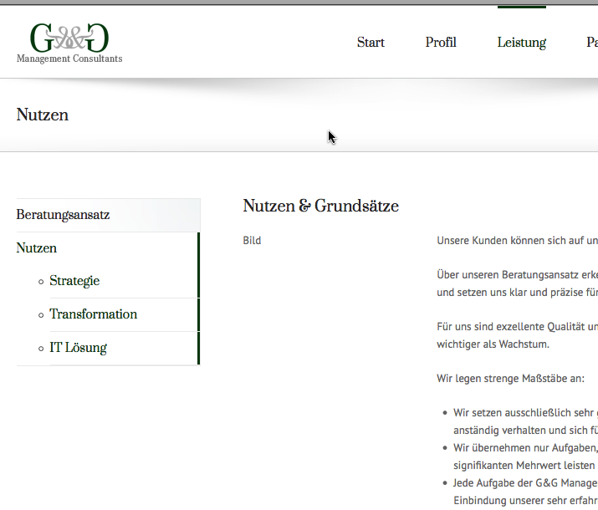

If I had clicked on any 3rd level point (Strategie), the 2nd level is not shown.
The status in the Top Menu is in the pull down menu correct but in the head the status line is not showing.
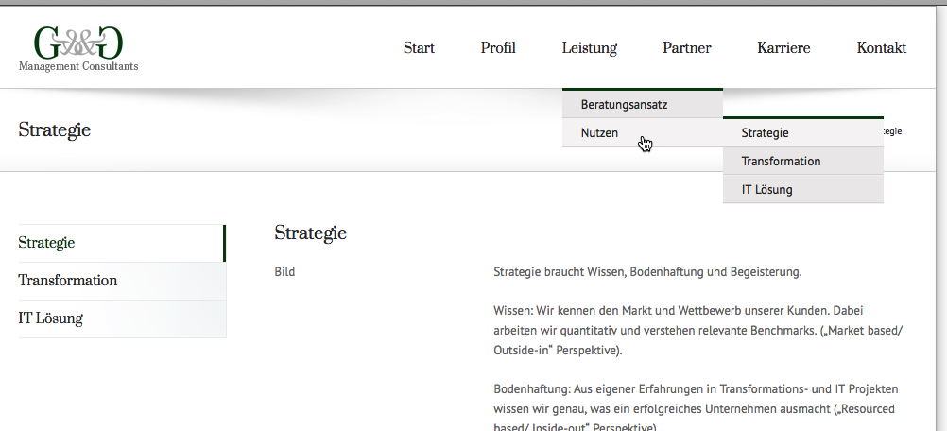
I think it must be look like this: (Photoshop) 3rd Level “Strategie” is clicked.
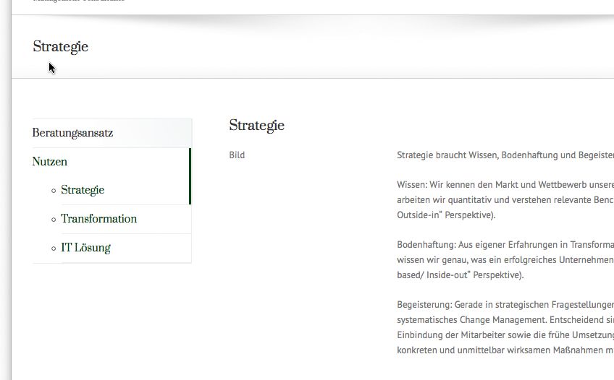

3) It is possible to change the headline text or is it only similar with the page name?
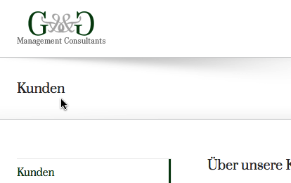

4) How can I implement the search form in the pages? Maybe under the navigation menu.

